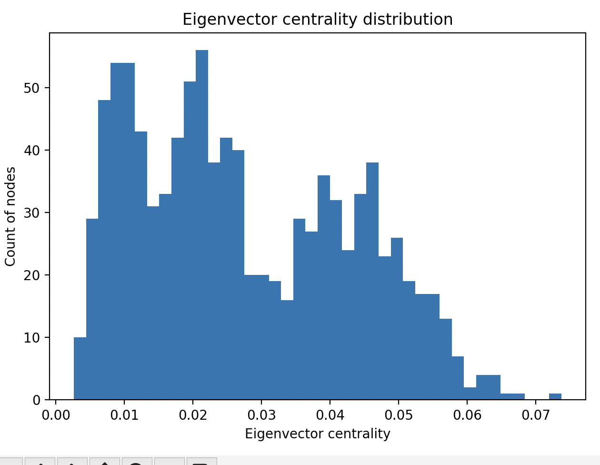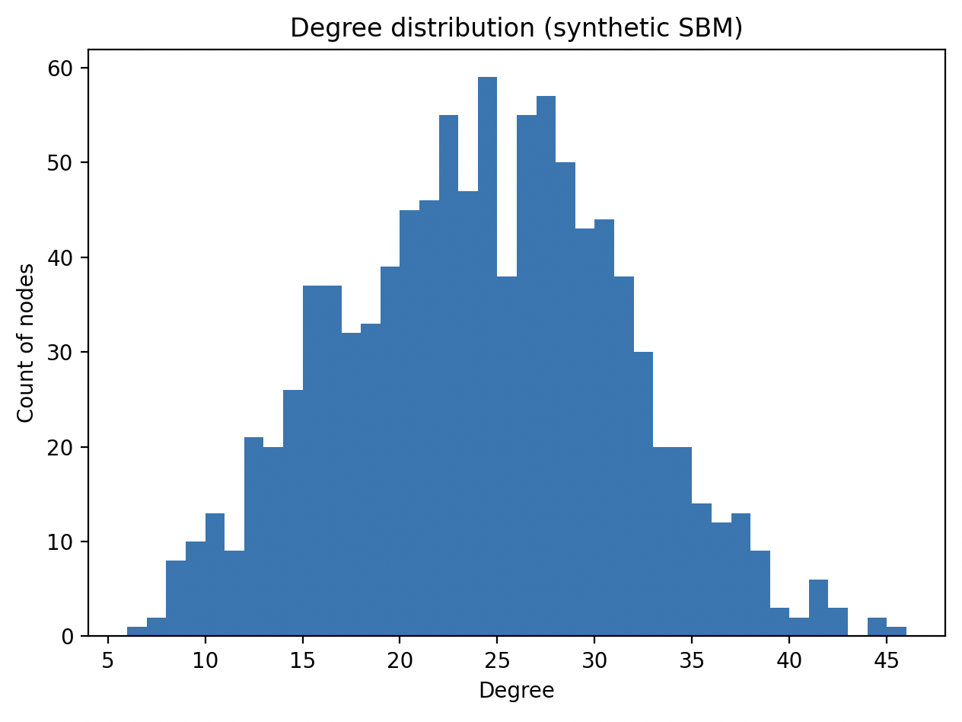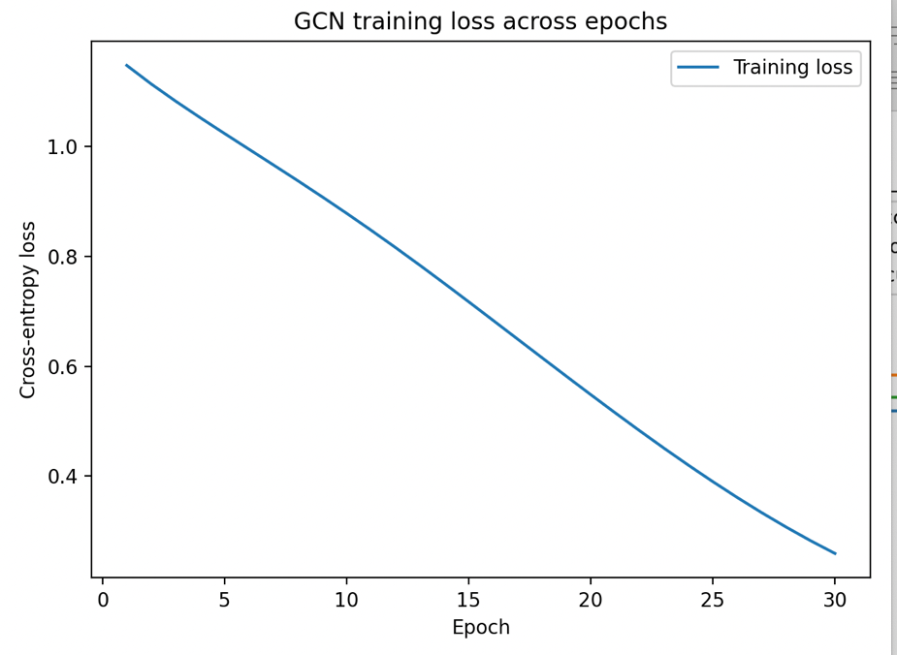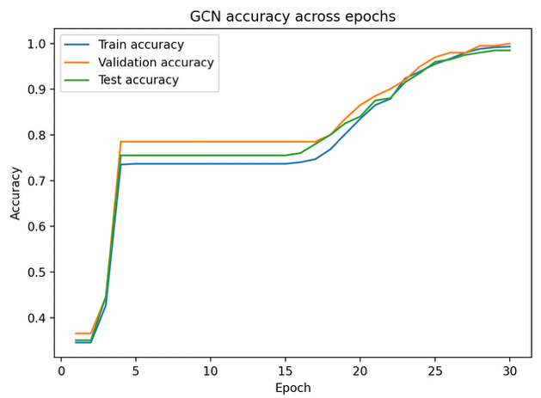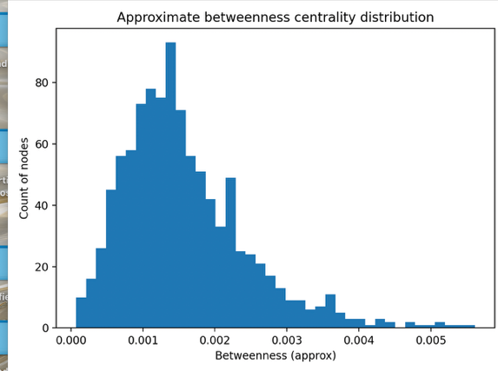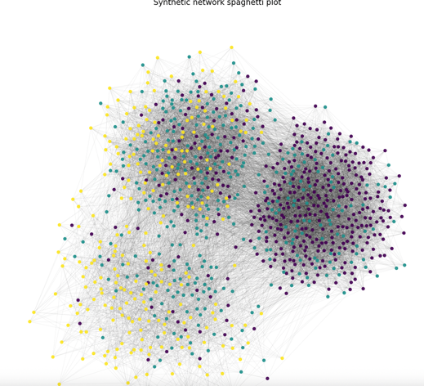

GNN can exploit can improve prediction by using the features of the nodes and edges. IN social science setting, one behavior is easily to be impacted by other persons, especially people who close to them including both geomatic and phycological, such classness may contain the homophily or similarity which may lead the GNN mislead the results.

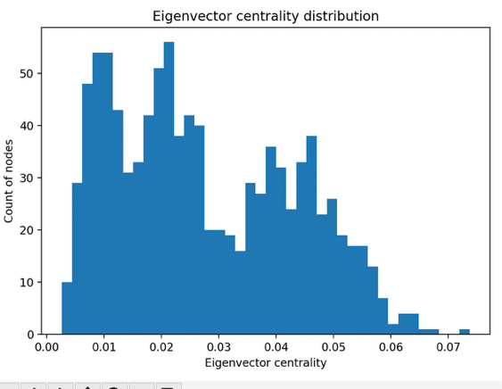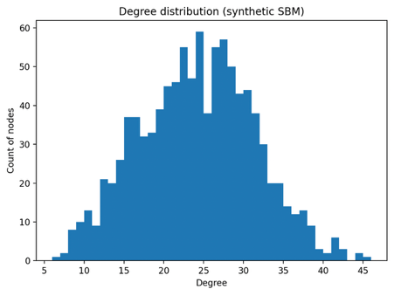

Top 10 nodes by degree:
[(394, 46), (352, 44), (129, 44), (5, 42), (390, 42), (197, 42), (291, 41), (236, 41), (530, 41), (285, 41)]

Top 10 nodes by betweenness centrality:
[(530, 0.005610088997141248), (352, 0.005421184059948497), (570, 0.0052710700766739685), (252, 0.005148088514661503), (129, 0.00511736069431368), (394, 0.005051362624028745), (280, 0.00490613147271233), (390, 0.004759279955994493), (291, 0.004664753727506496), (179, 0.004389393969650452)]

Top 10 nodes by eigenvector centrality:
[(394, 0.07373634147903953), (352, 0.06756680741018778), (5, 0.06496725295661636), (285, 0.06455829797667846), (146, 0.06413957438488921), (323, 0.06329197608600184), (129, 0.06319224661910523), (291, 0.06275947735948613), (197, 0.06267568735877985), (390, 0.06212223006764913)]
There are partially overlapped among three rankings, for instance 394, 129, etc., which indicating there are consistently important in the network. Degree centrality captures the direct connections among nodes, while betweenness assesses the indirect connection. For Eigenvector reflects a nodes importance based on its neighbors.
Question 5:
Community detection summary:
Number of Louvain communities: 3
Louvain community sizes (first 10): [400, 350, 250]

Adjusted Rand Index (Louvain vs truth): 1.0
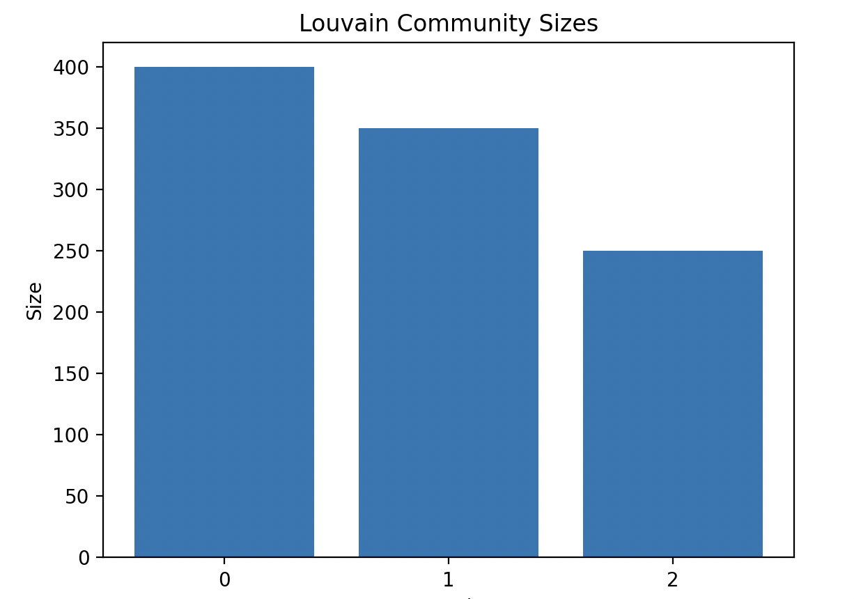

ARI measures the similarity between the detected communities and the true SBM. The number of ARI indicates that the Louvain algorithm exactly detects the true community structure. One reason is that the algorithm groups nodes based on observed connections rather than true labels. If there are relatively many connections between two communities, the algorithm may combine into one. Otherwise, the connections within the community are weak, it will split to smaller groups.

Question 6
Baseline LR test accuracy: 0.975
GCN test accuracy: 0.985

Validation accuracy: 1.000
Test accuracy: 0.985
GCN confusion table (test set):
Predicted 0 1 2
True
0 81 0 0
1 0 70 0
2 1 2 46
Predicted 0 1 2
True
0 81 0 0
1 0 70 0
2 1 2 46

GCN can outperform the baseline in this setting since it utilizes both node features and network structure, allowing it incorporate information from neighboring nodes through message passing. In this setting, nodes within the same community are strongly connected. One reason that the baseline might be competitive if the GCN overfit errors through the network. One caution about interpreting “high accuracy” as scientific validity in social network prediction tasks is it may be driven by homophily or data leakage instead of meaningful causal relationship.

